NEO Learning Systems

design document – Project Raptor

student app

April 2017

VERSION 1.2

CONFIDENTIAL

# Table of Contents

1 Table of Contents 2

2 Overview 3

2.1 Project Objectives 3

3 Student Role 4

3.1 Student Login 4

3.2 Agenda 7

3.3 Student Test 7

3.4 History 16

4 Non-Disclosure 18

# Overview

The Student App in Neo Learning Systems (NLS) will be undergoing some amount of rework and change to meet the requirements for the education market. Our software is directly tied to the Ontario standardized mathematics curriculum. The App provides user interfaces for students and parents.

Note: The parent’s part of the project will be developed at a later date.

## Project Objectives

The project must meet the following general objectives (specific objectives and project deliverables will be covered in other sections of this document).

* Change the UI to meet the guidelines set by the Ontario Curriculum
* Create the appropriate level of application security for the Students.
* Responsiveness of the Project for Students to be able to view in any device in Chrome browser.
* Deliver the changed functioning applications by July 2017.

# student Role

The following sub-sections correspond to the various screens or tabs that will change or require rework to the current implement app.

## student Login

The login screen for the Student App will now be same as the teacher, principal roles; pictured below in Figure 1. A student will login using his/her email-id instead of the user id as used in the other apps. Whenever a user logs out of the application, they should be brought back to this login screen and any session data stored within the browser should be deleted. If the user is inactive for more than 10 minutes the application should also auto log out and be redirected to the login page.



Figure 1: Login screen for the student user role

After logging in the student will view a menu which visually will be same as the teacher or principal app; picture shown below Figure 2. The menu includes only two modules for now Agenda and History, details for this will be explained further in the document.

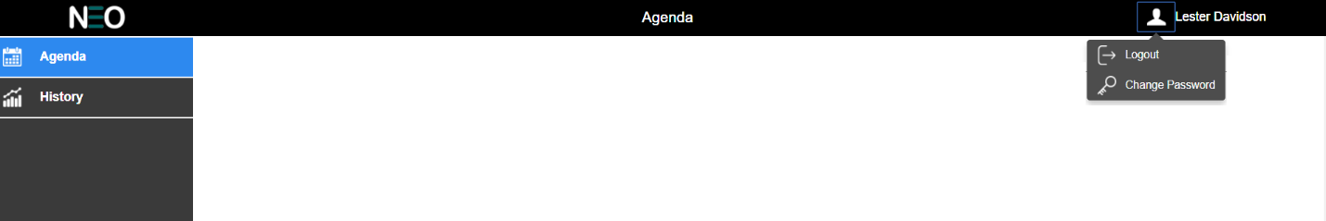

Figure 2: Menu screen for the student user role

### Logout and change password

Students can log out by clicking on their user icon on the top right corner of the screen. This will take the user to the login screen. They will also have the option to change their password.

Clicking on the icon will reveal the options to the user, Logout and Change Password as shown in Figure 2. The icons are available in GitHub.

Selecting the change password option will open a small dialog window (as shown in Figure 3 below) that asks the user to enter the following:

* Their existing password
* Their new password
* Confirm their new password

After this, they should click on the Okay button. Clicking the Okay button should first check that both new passwords are exactly the same, and if true and the old password is correct, then commit the new password to the database. If the new passwords do not match, or the old password is incorrect, an appropriate error should appear and give the user a chance to re-enter their new password.

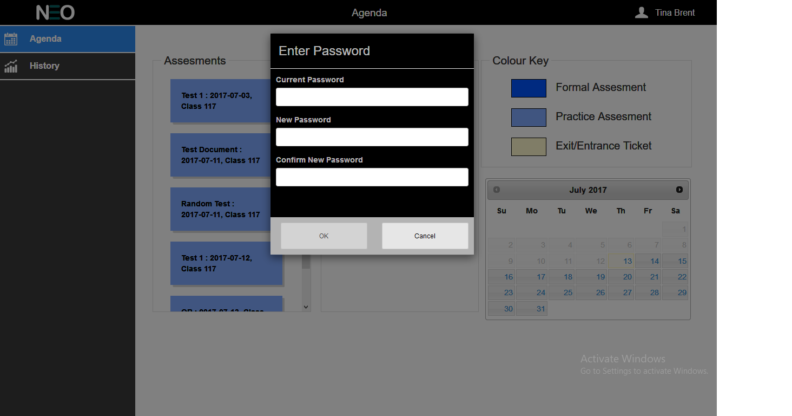

Figure 3: Change Password

### Browser Session Storage

The following values will need to be queried from the database after login and placed in the web browser’s session storage for later use on other pages:

| User ID | Role |
| --- | --- |
| First Name | Last Name |
| Location ID (for the school) | Location Name |

### Tables to Use

Query the following tables to retrieve the relevant data: User, ClassUser, Class, and Location.

**Additional Notes about this screen:**

* Part of milestone Release NeoStudents v1.2 due May 20, 2017.
* All logos, graphics and style files can be found within the application repository on GitHub.

## Agenda

The Agenda tab, pictured below in Figure 4, is used by students to view **active** Assessments and Exit Tickets only. The UI has been changed. The Agenda tab should be highlighted to indicate the user is in the Agenda page.

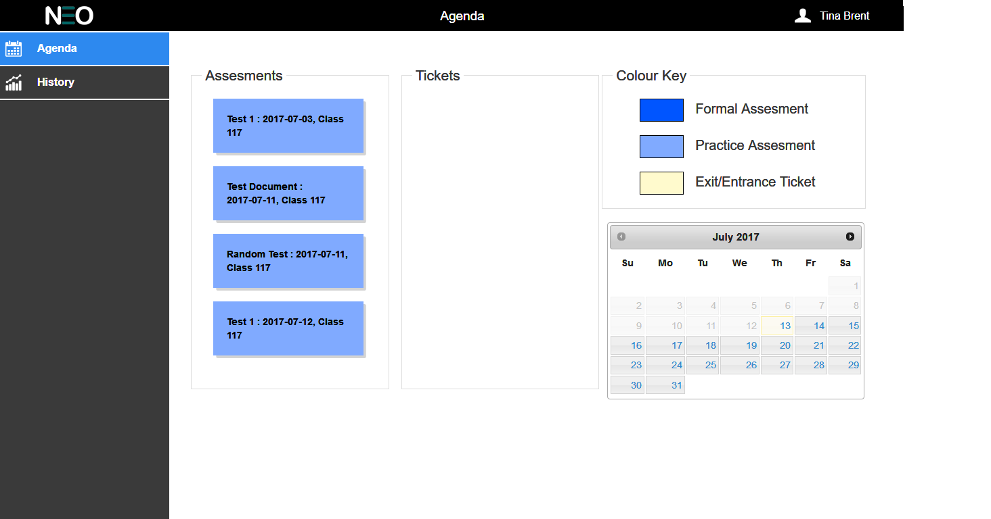

Figure 4: List of Assessments & Exit Tickets

The student will be allowed access only to current date Assessments or those Assessments that have not reached the end date that match the current date. These active assessments will be viewed in a place-card with background color #80AAFFfor practice assessments, #0055FF for Formal Assessments and #FFFACD for exit /entrance tickets. A legend table is to be displayed for indicating the type of assessments. A calendar will also be displayed on the right side of the list of assessments. This calendar will display the next 60 days from the current date. The user will not be allowed to scroll through the months of the Calendar. Tags for the respective assessments will be shown on the calendar as in the figure. These tags will display all the assessments, active and inactive for the two months shown.

On click of the Assessment or Exit Ticket, the Student test app will open within the same window. The design for the Student Test page has considerably changed and is explained below.

## student test

Details on the Student Test requirement details can also be found in the Project Raptor V1.10 document.

Clicking on the assessment will bring the logged in user to the first page of the test which will showcase the user details. The page will show details, the OEN number, First, Last name of the Student, the Grade and Course, as in Figure 5 shown below.

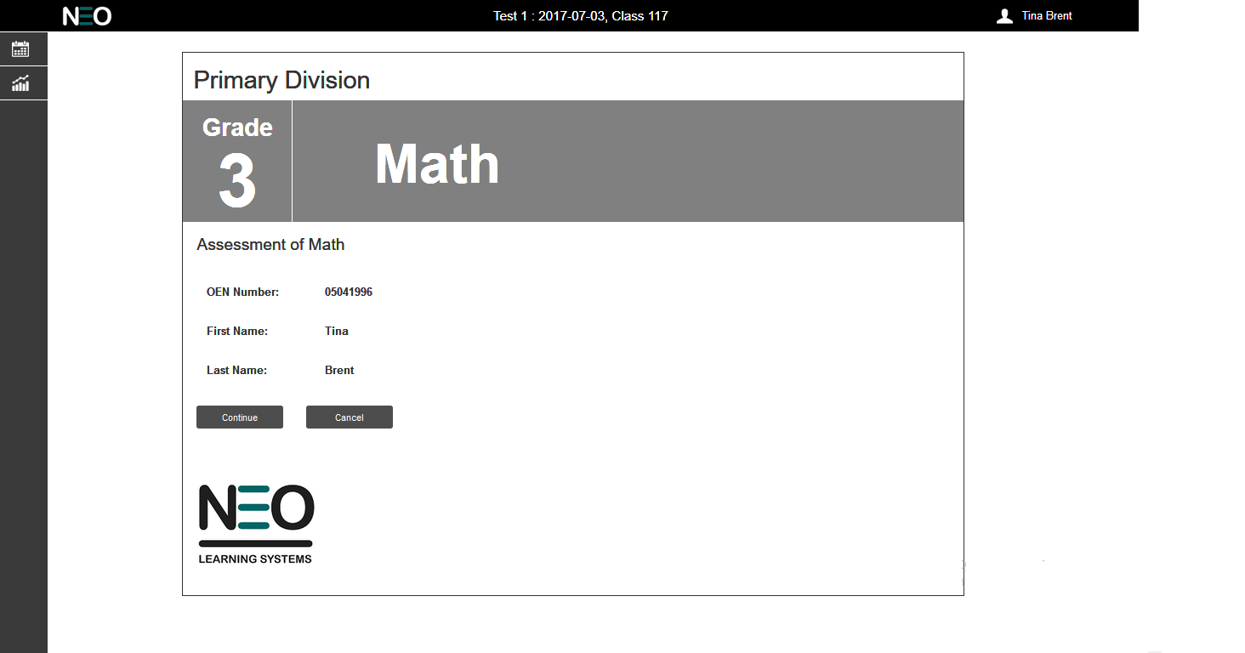

Figure 5: Student Details

The page header will show the assessment details i.e. the assessment name, date and class. The left side menu will decrease to show only the icons of the tabs.

Clicking on ‘Continue’ will take the student to the PIN number (if required) page of the test as in Figure 6 shown below or directly to the first page of the test. If the user clicks on ‘Cancel’, will take the user to the Agenda page where the assessment list is displayed for the user to select.

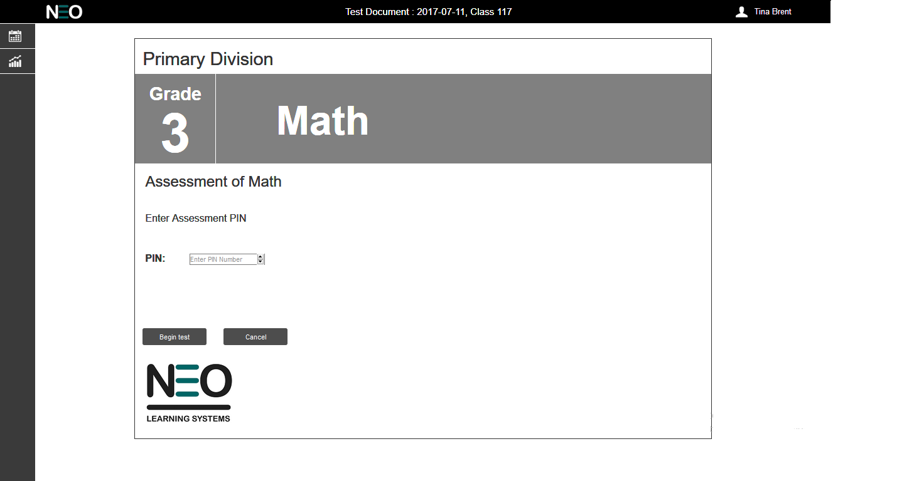

Figure 6: Pin Page

Once the user enters the test section and clicks on any other links of the app, like clicking on the Agenda & History icons or logout and change password options then a pop-window to be shown (as in figure 7 below) confirming that if they want to leave the page and that they will lose their test work.

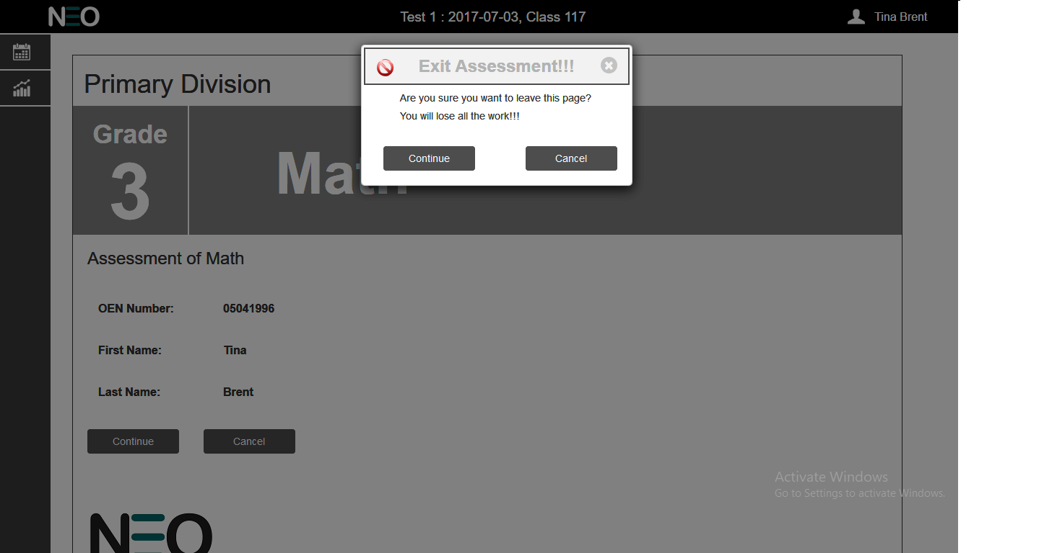

**Figure 7: Pop-up message**

Clicking on ‘Continue’ will take the user out of the test page and clicking on ‘Cancel’ will keep the user in the current test page.

Note: This is slightly different from the current flow of the student app.

Assessments for which the total questions are more than 20 questions should be split into 2 sections. Each section will contain half of the total number of questions. For example, a test with 25 questions would have 13 questions in Section 1 and the remaining 12 questions in Section 2.A banner stating “Section 2” will be shown before Section 2 begins as shown in figure 8.

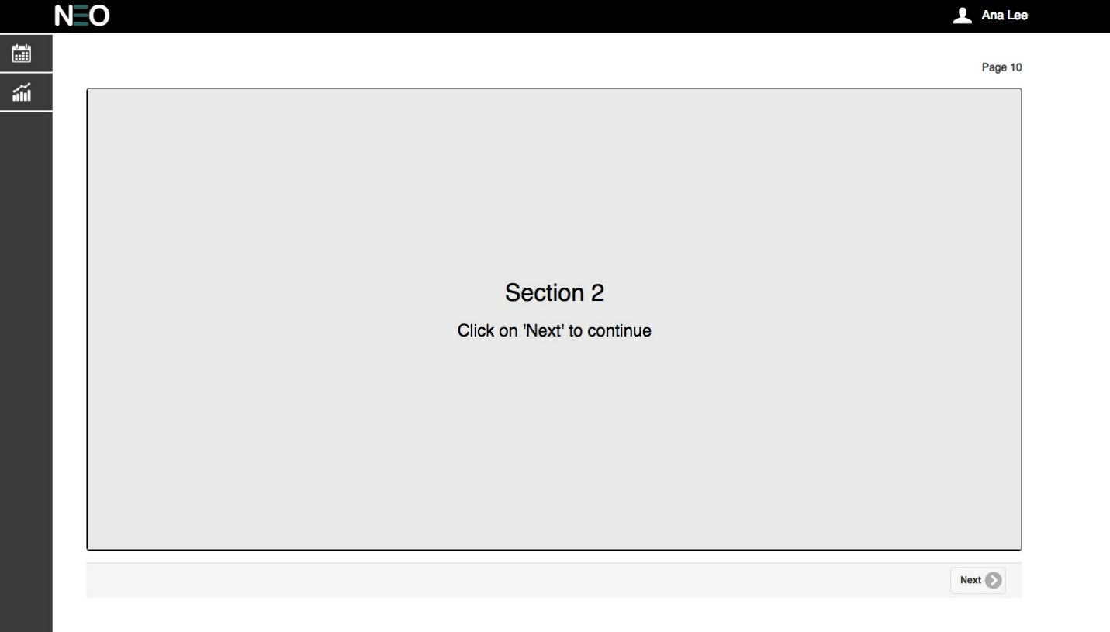

Figure 8: Section – 2

The question are further split between manipulative and non-manipulative type of questions. Every type has a header indicating the same before the set of questions as shown in figure 9 and figure 10.

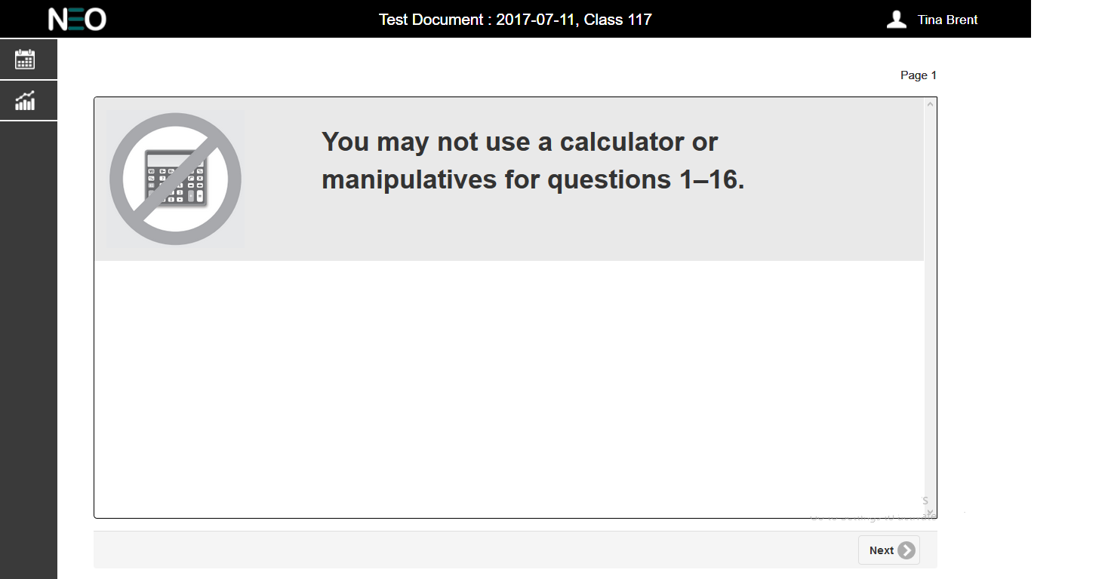

Figure 9: Non Manipulative

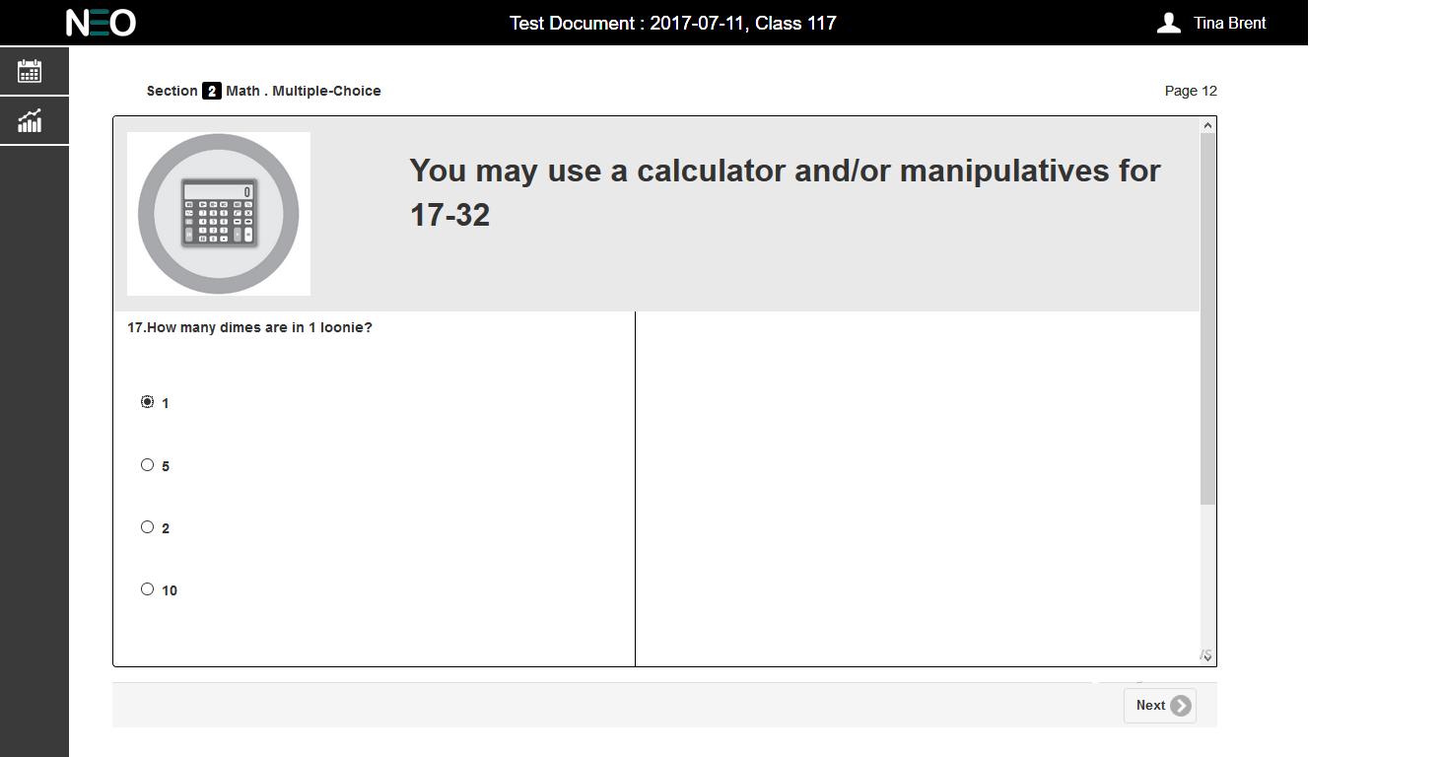

Figure 10: Manipulative questions

Clicking on ‘Next’ button takes the user into the questions pages. There are three types of questions, Multiple Choice (Figure 11), Text Input (Figure 12) and Open Response (Figure 13).

Multiple Choice questions are displayed 2 per page and each questions have an option of four answers of which the student can select only one option.

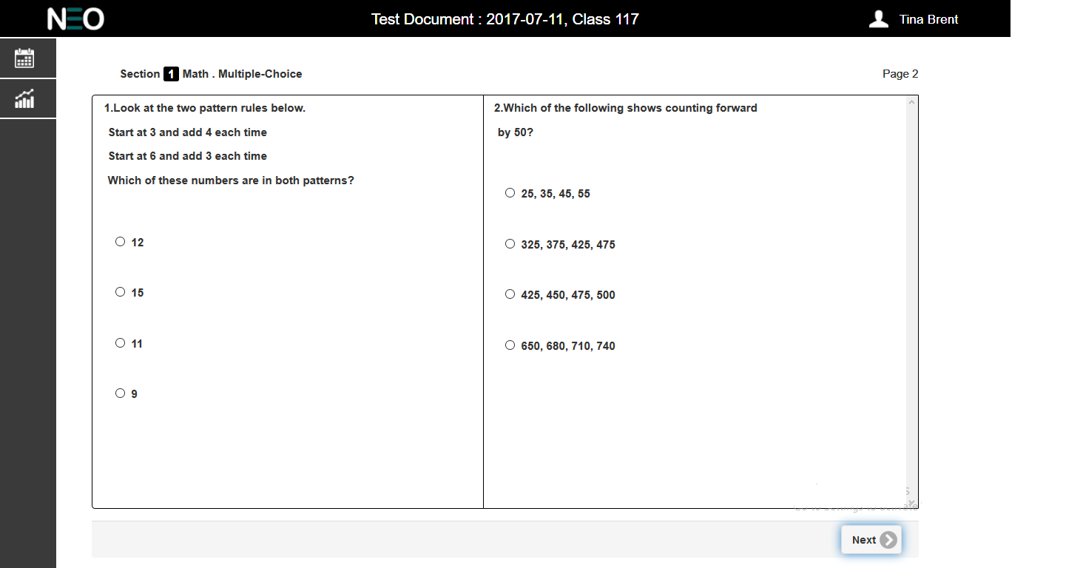

Figure 11: Multiple Choice

Input type questions have a final answer that student responses can be measured against and that they must type in. There is also a canvas area where they can write in to show their work.

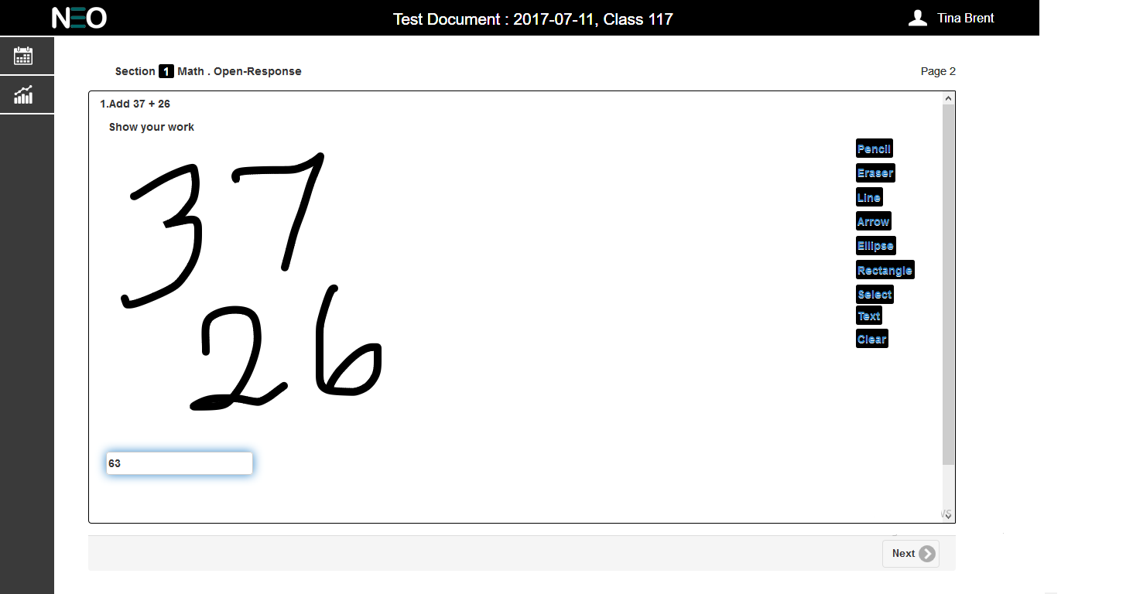

Figure 12: Input Type

The user will have to select an answer (Multiple Choice) or enter the answer (Input Type) before clicking on the ‘Next’ button to continue. If the user tries to continue a message ‘Answer is required’ is displayed to prompt the student to answer the questions.

Open-Response type questions have no final answer; rather they simply have an open area where the student can draw their response. These hand drawn responses are then manually scored by the teacher. In either case, displaying in the page header for the student assessment will be “Open-Response” for both of these question types (text input and open response).

For more detailed information please refer the ‘Open Response Requirements Version 1.1’.

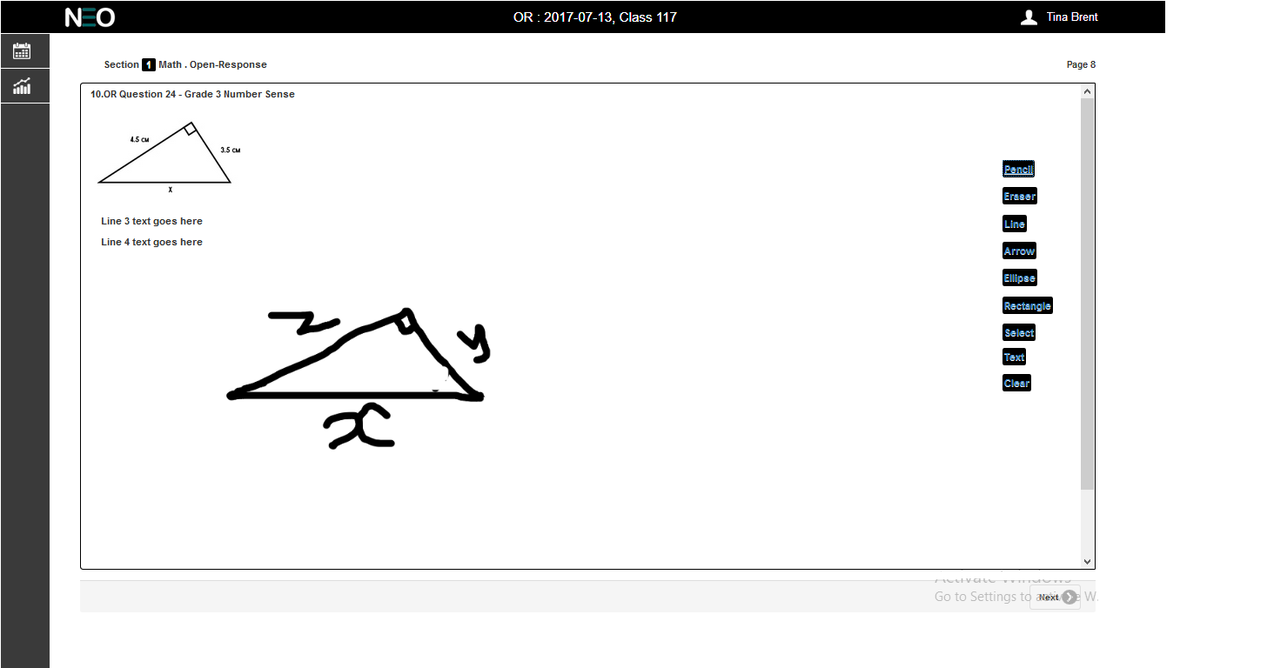

Figure 13: Open Response

Once the user starts Section 2 the title above the question box should change to Section 2 from Section1 as highlighted in figure 14. All other features remain same.

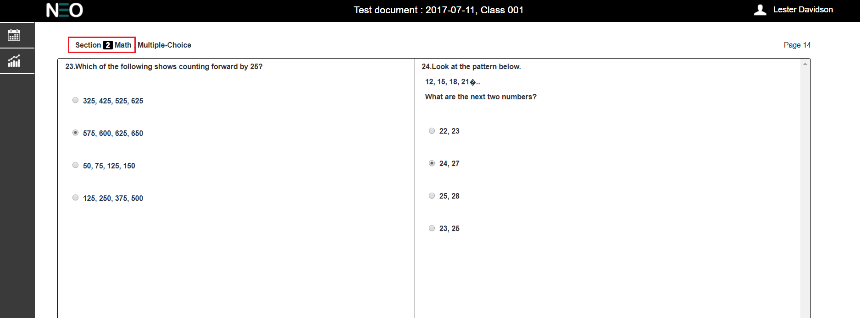

Figure 14: Section-2 begins

When the student completes the test as in Figure15 shown below and clicks on the ‘Mark your test’ button the user will be taken to the Show result page as shown in Figure 16.

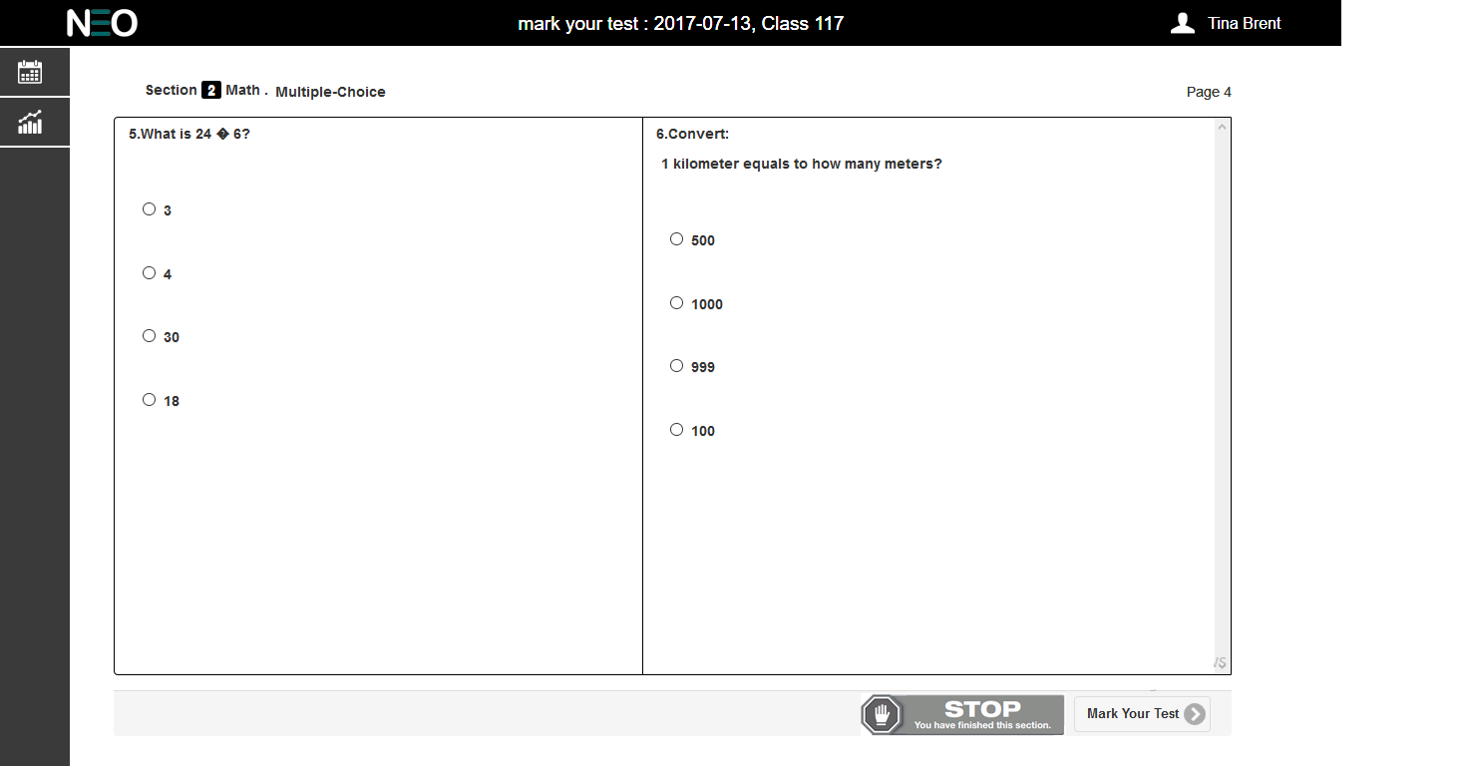

Figure 15: End of Test

If the teacher has selected the retest option then the student can take the test again by clicking ‘Try Again’ button.On clicking the ‘Submit’ button, the test is submitted and the user is taken back to the agenda.

Under 3 scenarios the test should be auto submitted:

**Scenario 1:** When retest is disabled and show result is selected, the test gets auto submitted.

**Scenario 2:** When retest and show result is disabled, the test gets auto submitted.

**Scenario 3:** when the test has an open-response type of question and retest is disabled, the test is auto submitted

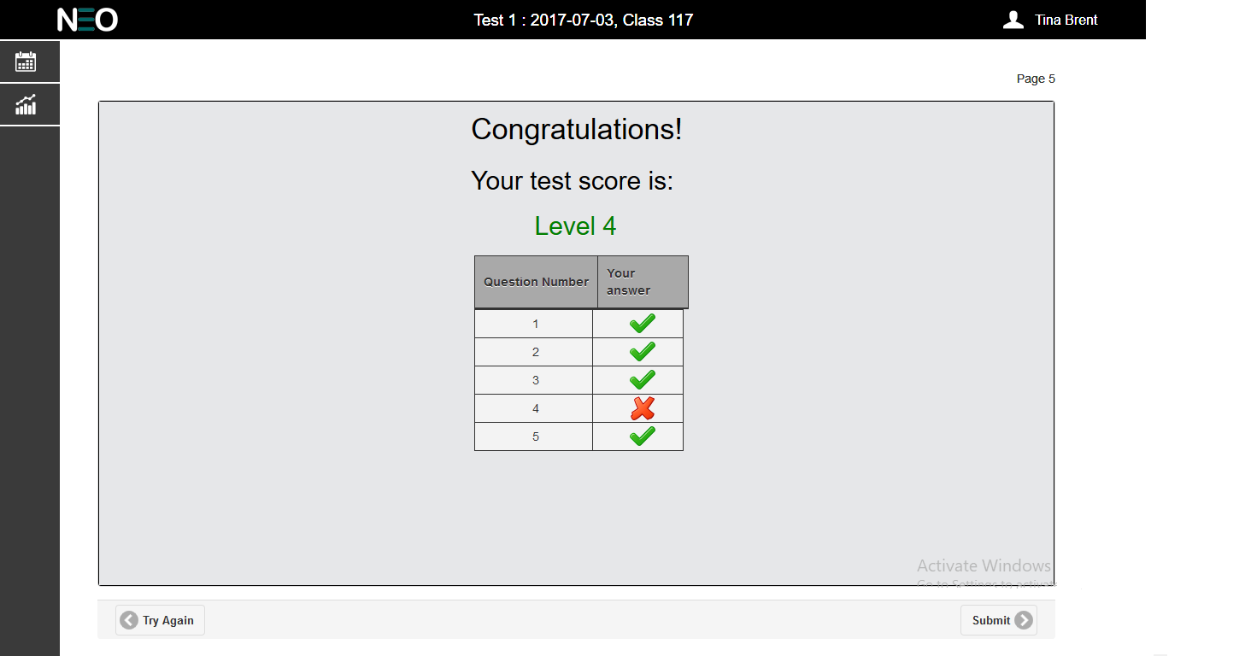

Figure 16: Show Result Page

When the show result option is selected the results are shown with the question number and the validity of the answer is displayed alongside. The level achieved in the test is also shown, which is calculated as shown below.

* Level 1 – Scores less than 50%
* Level 2 – Scores greater than and equal to 50% and less than 65%
* Level 3 – Scores greater than and equal to 65% and less than 75%
* Level 4 – Scores greater than and equal to 75%

## History

The History tab, Figure 17 below, will display to the logged in student their assessment results till date. All data in this screen will be read only. There will a single filter ‘Class’ to display, but no further drill downs for the chart. The ‘Class’ dropdown will display all the classes the logged in student in currently enrolled in. By default the first class on the list should be selected and the corresponding result chart to be displayed below. The chart below should be displayed depending on the class selected by the user. The displayed assessments should be a date sensitive list. The valid dates for this list of assessments should be between the Start Date and End Date of the logged in students class; this data can be found in the database Class collection. The individual score bars should be color coded by test type (Formal, Practice, Out of grade) as per table.

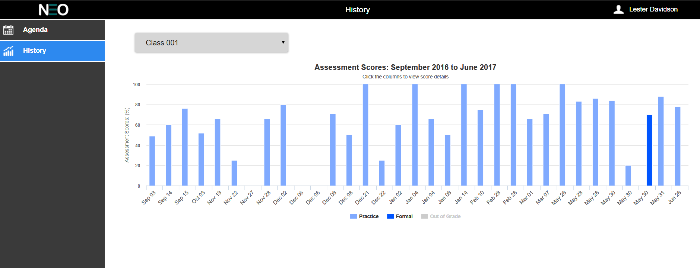

Figure 17: History

The graph title should read ‘Assessment Scores:’ followed by the first and last month of the student’s assessments. The y-axis should read Assessment Score (%) and display data from 0 to 100 with intervals of 20. The x-axis should read the assessment’s start date of the assessment.

Rolling the mouse pointer over a specific bar should reveal a tooltip with specific information about thatdata point (see Figure 18below). The tooltip should have a title (Assessment Score), the specific test date, and the percent for the student on that test.

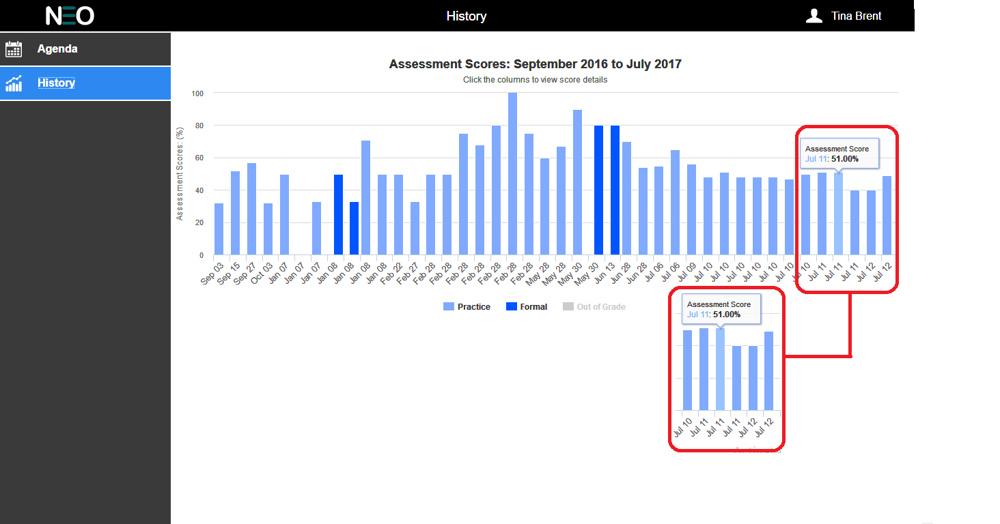

Figure 18: Tool Tip for Assessment Score

The color chart in the following section shows the details on color codes for the test types.

|  |  |  |
| --- | --- | --- |
| Practice Assessment | #80AAFF |  |
| Practice Assessment Rollover | #B3DBFF |  |
| Formal Assessment | #0055FF |  |
| Formal Assessment Rollover | #B3DBFF |  |
| Outgrade Assessment | #D6D6D6 |  |
| Outgrade Assessment Rollover | #EFEFEF |  |

Table 1: Assessment Graph Colour Palette

# Non-Disclosure

All of the information within this document is considered to be confidential and the property of NeoLearning Systems. The software developer will treat this document, and any other information or materials disclosed or provided, as private and confidential and will not disclose, reproduce or transmit said information and materials to any other party without the written consent of Neo Learning Systems.

It is the responsibility of the software developer to ensure that all materials provided are returned to Neo Learning Systems.